# Lab documentation Table of contents

LAB

Resource Visualizer  creating firewall

Communications

 VM to Local Machine

 Local Machine to VM through Firewall

Rules

 NAT rules

 Network collection rules

# LAB

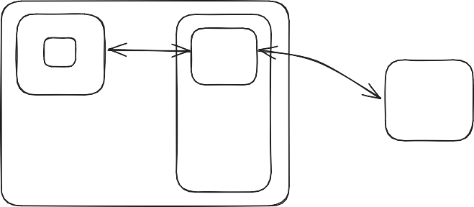VM firewall

Local Machine

# Resource Visualizer

# 

**creating firewall**

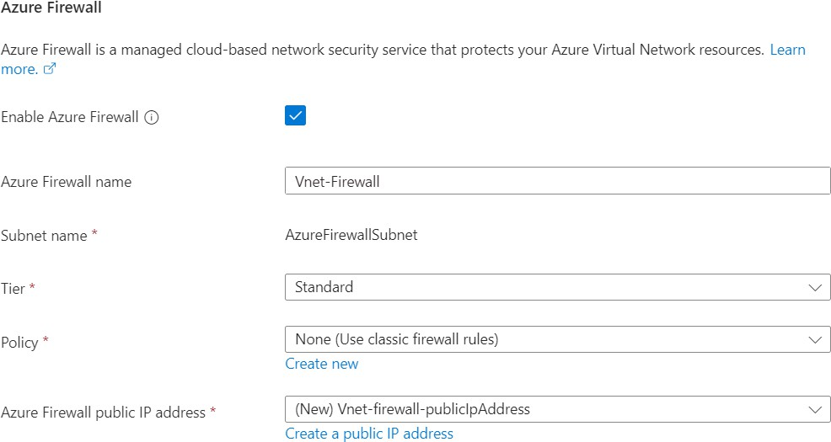

# Communications

**VM to Local Machine**

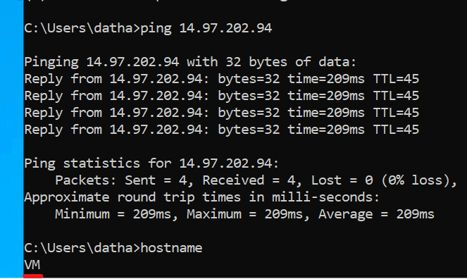

**Local Machine to VM through Firewall**

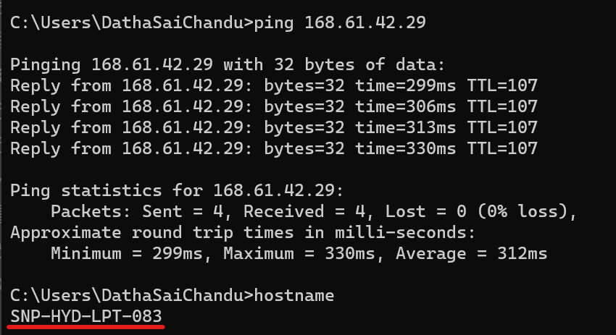

# Rules

**NAT rules**



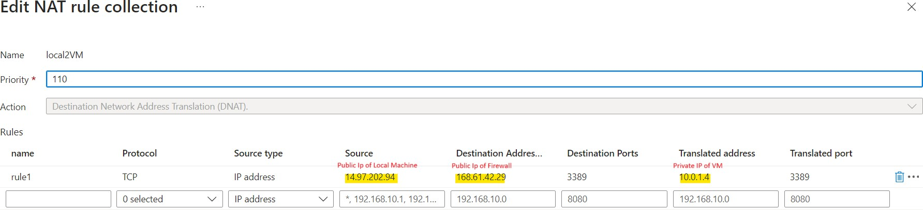

**Network collection rules**

